273/2
Geography
Paper 2
July/August 2019
2½ hours

BUGANDA EXAMINATIONS COUNCIL MOCKS

Uganda Certificate of Education

GEOGRAPHY

PAPER 2

2HOURS 30 MINUTES

INSTRUCTIONS TO CANDIDATES

- Answer four questions only
- Choose two questions from part I and two from part II.
- In part II, only one question should be chosen from any one region.
- Any additional question(s) answered will not be marked.

PART I: THE REST OF AFRICA
Answer two questions in this part.

1.
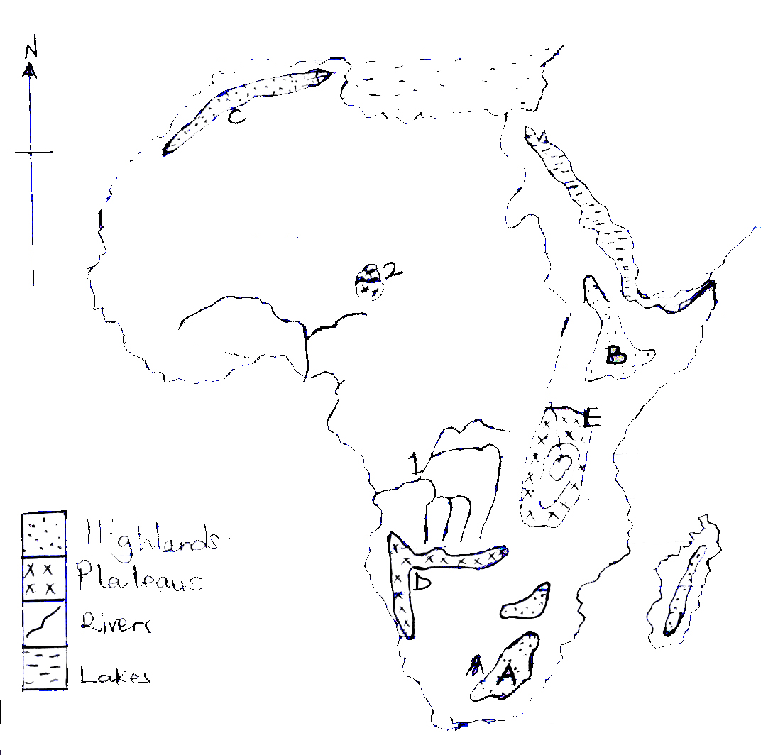
Study figure 1, map of Africa provided and answer the questions that follow

(a)(i) Name the highlands marked A, B and C (03marks)
(ii) Plateaus marked D and E. (02marks)
(iii) River marked 1 (01mark)
(iv) Lake marked 2 (01mark)
(b) Describe the process which led to the formation of Cape Ranges in South Africa.
(06marks)
(c) Explain the importance of highland areas of Africa. (08marks)
(d) Outline the challenges faced by people living in highland areas of Africa. (04marks)

2(a) Draw a sketch map of Nigeria and on it mark and name;
- Areas occupied by the Fulani
- Rivers; Niger and Benue,
- Towns; Abuja and port Harcourt,
- Any two neighbouring countries. (08marks)

(b) Describe the conditions which have led to the practice of trans-humance among the Fulani in Nigeria. (06marks)

(c) Explain the effects of normadism on the environment in Nigeria. (06marks)

(d) Outline the steps being taken to improve the livestock industry in Nigeria. (05marks)

3(a) Draw a sketch map of Ghana and on it mark and name;
- Cocoa growing area
- Ports Takoradi and Tema
- Lake Volta
- Akosombo dam (06marks)

(b) Describe eth factors which have favoured cocoa growing in Ghana. (08marks)

(c) Explain the problems facing cocoa growers in Ghana. (06marks)

(d) What measures are being taken to increase cocoa production in Ghana? (05marks)

4. Study table 1 below showing copper production in Zambia and answer the questions that follow;
Table: Zambia: Copper production 1975 – 90 (‘0005 metric tons)
Year | Annual Production ‘0005 metric tons
1975 | 676.9
1980 | 595.8
1985 | 452.6
1990 | 445.0
Source: World Resources: A Guide to Global Environment (1992 – 3) towards sustainable Development: Oxford P.320.

(a) Draw a bar graph to show the information given in the table. (05marks)

(b)(i) Describe the factors that have favoured copper production in Zambia. (06marks)
(ii) Explain the contributions of the mining sector to the development of Zambia.(6marks)

(c) Outline the problems facing the mining sector in Zambia. (05marks)
(ii) What steps are being taken to solve the problems in C (i) above? (03marks)

PART II: STUDIES IN DEVELOPMENT
Answer two questions from this part
REGION 1: NORTH AMERICA
5. Study figure 2, map showing the Southern U.S.A and answer the questions that follow.

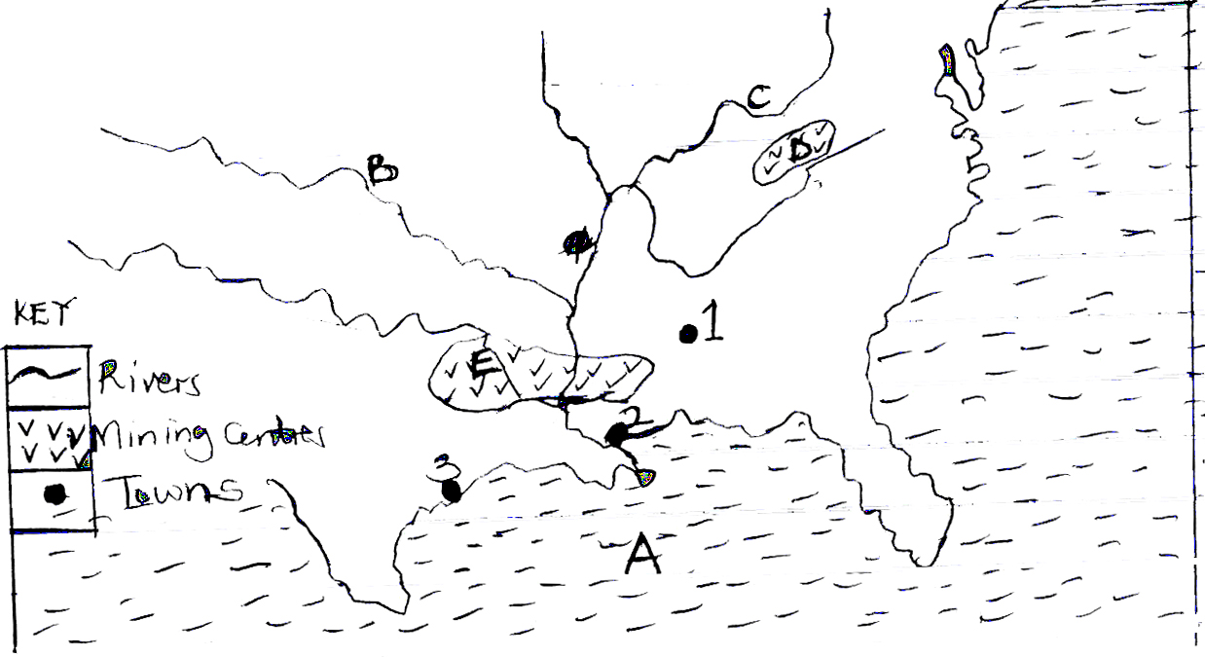

(a) Name the;
(i) gulf marked A (01mark)
(ii) rivers marked B and C. (02marks)
(iii) minerals obtained from areas marked D and E. (02marks)
(iv) industrial centres 1, 2 and 3. (03marks)
(b)(i) State any three types of industries found in the South. (03marks)
(ii) Describe the factors which have led to the development of industries in the South.
(08marks)
(c) Explain the benefits resulting from the establishment of industries in the South
(06marks)
6. Study table 2 below showing Canada’s Wheat export routes and answer the questions that follow.
Routes | Percentage of wheat exported
Eastern | 51
Western | 45
Northern | 04
Total | 100

(a) Draw a pie-chart using the table above to show the relative importance of Canada’s wheat export routes. (06marks)

(b) Name any;
(i) one port found at the terminal of each export route. (03marks)
(ii) three countries which import Canadian wheat. (03marks)

(c)(i) Explain the factors which;
(i) Have favoured the use of the Eastern export route. (05marks)
(ii) Limited the use of the Northern export route. (05marks)

7(a) What is a Multi-purpose scheme? (02marks)
(ii) Name any one multi- purpose scheme in North America. (01mark)

(b) Describe the measures taken by the Tennessee Valley Authority to address the problems of environmental degradation. (08marks)
(c) Explain the;
(i) benefits which resulted from the establishment of the Tennessee Valley Multipurpose scheme. (06marks)

(ii) Outline the problems that resulted from establishment of the scheme. (04marks)

(d) What measures have been taken to solve the above problems? (04marks)
REGION II: THE RHINE LANDS
8. Study table 3 showing in-bound tourists (‘000S) for the Rhine lands and East Africa and answer the questions that follow;

Table 3: In-bound Tourists in 2001 (‘000S)

Region | Country | In-bound tourists
Rhine lands | Belgium  Netherlands  Switzerland | 6,452  9,500  10,700
East Africa: | Uganda  Kenya  Tanzania | 205  841  501

Adopted: 2003 World Development Indicators.
The World Bank, Washington D.C pp.352 – 354

(a) Draw a line graph to represent the information given in the table. (07marks)

(b) Identify the country with the;
(i) largest
(ii) smallest
number of in-bound tourists. (02marks)

(c) Describe the factors which have led to the more tourists visiting the country indentified in (b) (i) than in b (i) above. (08marks)

(d)(i) Identify any two tourist attractions found in both the Rhine lands and East Africa. (02marks)

(ii) Explain the reasons for the low level of development of tourism industry in East Africa.
(06marks)

9(a) Draw a sketch map of Luxembourg and on it mark and label areas of;
- High population density
- Medium population density
- Low population density
- Three neighbouring countries
- Rivers; Sure and Alzette
- Luxembourg city (10marks)

(b) Describe the factors responsible for a high population density in some parts of Luxembourg. (05marks)

(c) Outline the challenges of a high population in Luxemburg. (05marks)
(d) What measures have been taken to reduce the challenges above? (05marks)
10(a) Describe the factors that favoured the development of port Rotterdam. (08marks)
(b) Explain the importance of Rotterdam port. (06marks)
(c) What challenges are faced by the people using Rotterdam? (06marks)
(d) Outline the measures being taken to solve the challenges above. (05marks)

REGION III : CHINA
11(a) Draw a sketch map of China and on it mark and name;
- River Yangtze and Huang he
- The Grand Canal
- Cities, Beijing, Shangai, Shenyang and Guangzhou
- Areas for sugar cane plantation. (09marks)
(b) Describe the factors which have favoured agriculture in the Yangtze delta region. (06marks)
(c) Explain the contribution of agriculture to the development of Yangtze delta.(06marks)
(d) Outline the problems faced by farmers in the Yangtze region. (04marks)
12. Study table V below showing the climatic statistics of Canton in the R.Sikiang delta and answer the questions which follow.
Table V : Climate of Canton (River Sikiang Delta)
Month | J | F | M | A | M | J | J | A | S | O | N | D
Temp(ºC) | 13.3 | 13.9 | 17.2 | 21.7 | 26.7 | 27.2 | 28.3 | 26.7 | 23.9 | 19.4 | 15.6 | 14.0
R.F(mm) | 23 | 48 | 107 | 173 | 269 | 260 | 205 | 219 | 165 | 86 | 31 | 23
Source; Tregear; T.R (1980) China: A Geographical Survey P.303.
(a) Draw a suitable graph to show the climate of the station. (08marks)
(b) Calculate the mean annual
(i) rainfall,
(ii) temperature
(iii) range of temperature for the station. (03marks)
(c) Describe the characteristics of the climate of the area where the station is located. (08marks)
(d) Explain the influence of climate on the development of agriculture in the River Sikiang delta. (06marks)

13. Study the figure 3 below; map showing river Yangtze basin and its developments and answer the questions that follow;
A
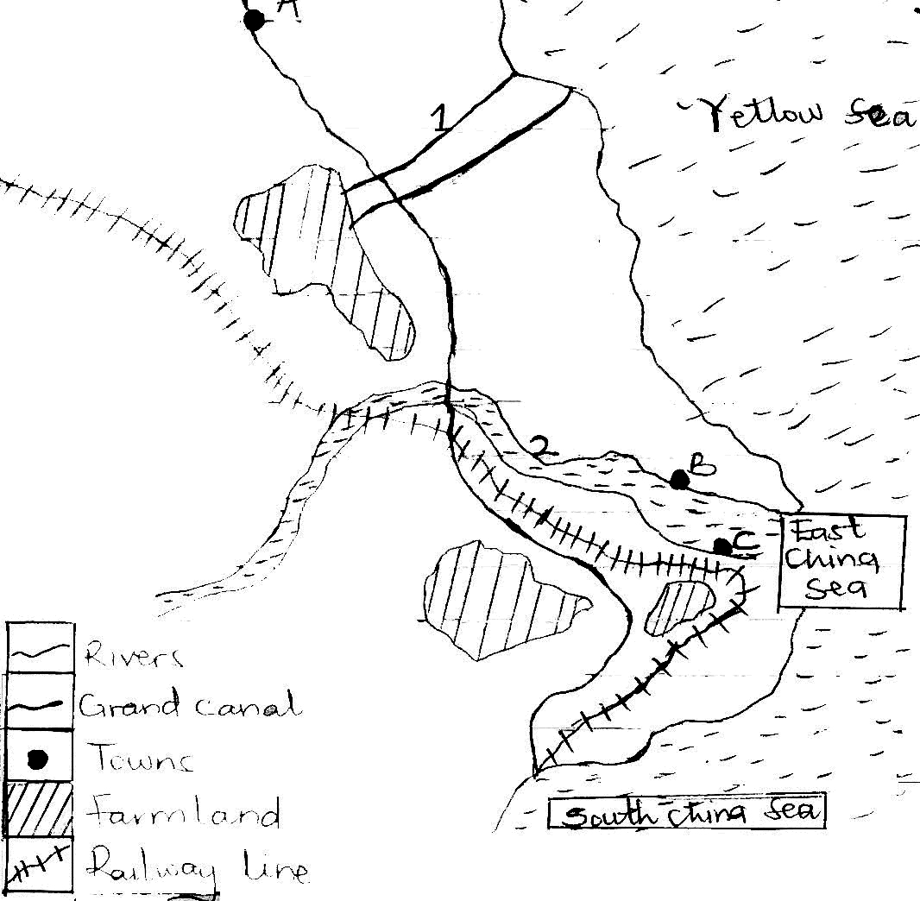

(a) Name the;
(i) towns marked A, B and C.
(ii) rivers marked 1 and 2 (05marks)
(b) Explain the importance of rivers to China. (08marks)
(c) Describe the problems hindering the use of China’s rivers. (06marks)
(d) Outline the measures taken to solve the above problems. (04marks)

END

